Kendall tau-b: EURUSD and USDCAD
Method 03 / daily log returns / Alpari D1 full available history

Study setup
Logical pair: EURUSD , USDCAD
Broker symbols: EURUSD_i , USDCAD_i
Snapshot: 2026-11-03_majors_alpari_D1
Timeframe: D1
Matched return window: 1999-01-05 to 2026-11-02 (UTC bar dates)
Matched return count n: 7188
Dropped unfinished last bar dated 2026-11-03 UTC after a tick-volume check against the prior complete day.
Distinct log-return values that repeat: EURUSD=2, USDCAD=9
Complete matched rows (Excel): EURUSD-USDCAD_Kendall_D1.xlsx
Complete matched rows (HTML table): EURUSD-USDCAD_Kendall_D1_data.html

Method carried forward
Kendall tau-b counts concordant versus discordant unordered day pairs on matched daily log returns of close, ln(close_t / close_t-1), in the broker quote direction, with a tie-adjusted denominator. Quotes are not inverted. tau-b is symmetric under swap of the two symbols. tau-b = 0 means concordant and discordant counts balance in this sample; it does not mean no link of any kind. The score is not a cause, not a lead, and not a trading signal. Daily rows are not independent draws, so the two-sided p-value and approximate Bonett-Wright interval are reported and treated as secondary to tau-b. Same-sample Pearson r is shown only as a side check; a large tau-b minus r gap can flag outliers or a non-straight link.

Results
Kendall tau-b: -0.295698
Two-sided p-value: 2.55914e-309
Approximate 95% Bonett-Wright interval: [-0.309584, -0.281686]
Same-sample Pearson r: -0.456626
tau-b minus r: 0.160927

Conclusion
Over 7188 matched daily log-return rows for EURUSD and USDCAD (broker quote directions unchanged), Kendall tau-b is -0.2957 (negative, weak concordance association in this sample). Approximate 95% Bonett-Wright interval: [-0.3096, -0.2817]. Same-sample Pearson r is -0.4566 (tau-b minus r = 0.1609). Two-sided p under the usual independent-pairs model is 2.559e-309; that model does not match linked daily FX returns, so treat p as secondary. This does not establish cause, lead-lag, or a lasting trading rule.

Charts
Daily closes

Daily log returns
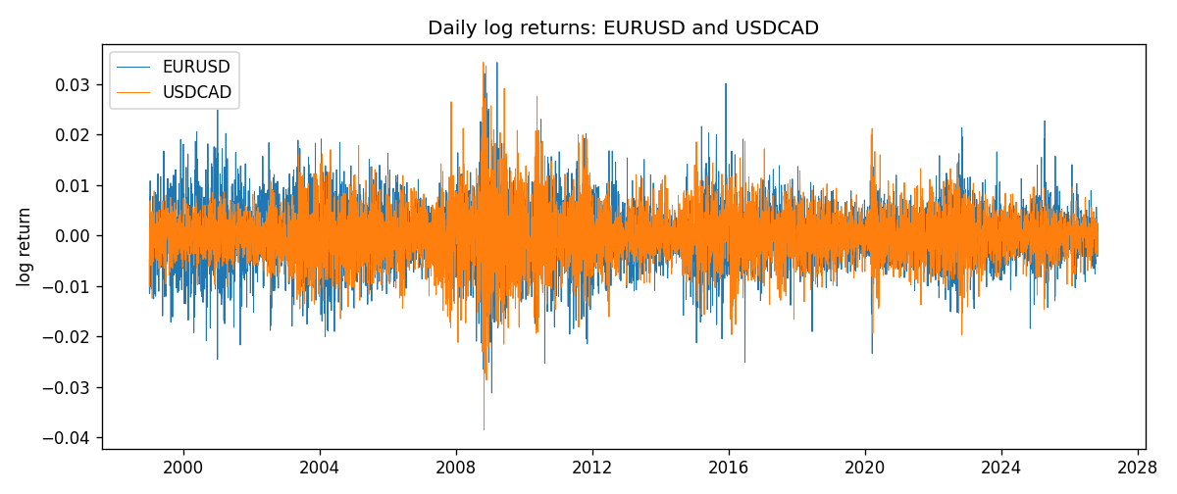
Log-return scatter
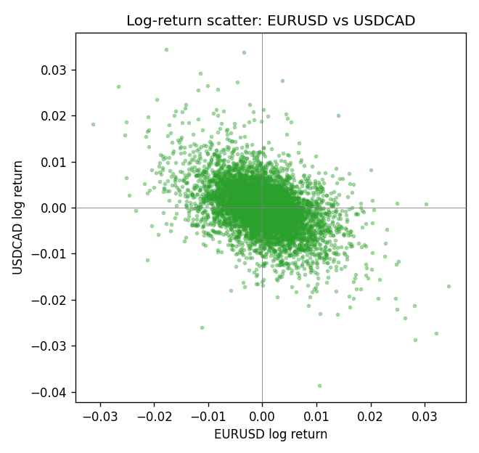

Data report
Every matched row that entered Kendall tau-b is stored in the sibling Excel workbook named EURUSD-USDCAD_Kendall_D1.xlsx. That file is the complete data archive for redrawing charts. Embedding all rows as a Word table is impractical at this length; the Word file holds the column list, column summaries, and the first and last 15 matched rows.
Columns: time, EURUSD_open, USDCAD_open, EURUSD_high, USDCAD_high, EURUSD_low, USDCAD_low, EURUSD_close, USDCAD_close, EURUSD_tick_volume, USDCAD_tick_volume, EURUSD_spread, USDCAD_spread, EURUSD_real_volume, USDCAD_real_volume, EURUSD_log_return, USDCAD_log_return
Column summaries (matched calculation rows)
column | count | mean | std | min | 25% | 50% | 75% | max
EURUSD_open | 7188 | 1.1814345 | 0.15078289 | 0.8272 | 1.086195 | 1.16617 | 1.2939425 | 1.5995
USDCAD_open | 7188 | 1.2667783 | 0.16890181 | 0.9168 | 1.1183975 | 1.298465 | 1.37211 | 1.6183
EURUSD_high | 7188 | 1.1865652 | 0.15138546 | 0.8326 | 1.0902775 | 1.17128 | 1.2993025 | 1.6038
USDCAD_high | 7188 | 1.2716763 | 0.16885945 | 0.9336 | 1.12285 | 1.30387 | 1.37649 | 1.619
EURUSD_low | 7188 | 1.1764236 | 0.15010221 | 0.8227 | 1.0820675 | 1.16257 | 1.2883725 | 1.5865
USDCAD_low | 7188 | 1.26222 | 0.16893673 | 0.9056 | 1.114065 | 1.293535 | 1.367805 | 1.6102
EURUSD_close | 7188 | 1.181473 | 0.1507571 | 0.8267 | 1.0860725 | 1.166175 | 1.2939575 | 1.5997
USDCAD_close | 7188 | 1.2667932 | 0.16887388 | 0.916 | 1.118295 | 1.29844 | 1.372365 | 1.6137
EURUSD_tick_volume | 7188 | 103177.84 | 173518.96 | 218 | 9407.75 | 52764 | 99553.25 | 1471626
USDCAD_tick_volume | 7188 | 81016.727 | 147303.02 | 37 | 5545 | 40941.5 | 71627 | 1410818
EURUSD_spread | 7188 | 19.349471 | 16.556644 | 0 | 8 | 12 | 30 | 50
USDCAD_spread | 7188 | 23.444073 | 18.266035 | 0 | 9 | 17 | 40 | 60
EURUSD_real_volume | 7188 | 4.031926e+10 | 1.6689501e+11 | 0 | 0 | 0 | 0 | 3.6149665e+12
USDCAD_real_volume | 7188 | 1.8376704e+10 | 9.6688094e+10 | 0 | 0 | 0 | 0 | 2.5751613e+12
EURUSD_log_return | 7188 | -7.59e-06 | 0.00580128 | -0.03123819 | -0.0032472 | 0 | 0.00325412 | 0.03433183
USDCAD_log_return | 7188 | -1.518e-05 | 0.00514306 | -0.03859748 | -0.00283637 | 4.741e-05 | 0.00272353 | 0.03436319
First 15 matched rows (selected columns)
time | EURUSD_close | USDCAD_close | EURUSD_log_return | USDCAD_log_return | EURUSD_tick_volume | USDCAD_tick_volume
1999-01-05 | 1.1758 | 1.5123 | -0.0048360507 | -0.010131666 | 4793 | 1345
1999-01-06 | 1.1623 | 1.5118 | -0.011547966 | -0.0003306769 | 4828 | 1803
1999-01-07 | 1.1712 | 1.5141 | 0.0076280636 | 0.0015202092 | 5076 | 1568
1999-01-08 | 1.1585 | 1.511 | -0.010902799 | -0.0020495197 | 5120 | 914
1999-01-11 | 1.1503 | 1.5057 | -0.007103287 | -0.0035137769 | 4960 | 953
1999-01-12 | 1.1555 | 1.5157 | 0.0045103728 | 0.0066194721 | 5248 | 1507
1999-01-13 | 1.1681 | 1.5226 | 0.010845346 | 0.0045420214 | 6623 | 2141
1999-01-14 | 1.1681 | 1.5332 | 0 | 0.0069376546 | 5472 | 1816
1999-01-15 | 1.1563 | 1.5245 | -0.010153245 | -0.0056905671 | 6529 | 1897
1999-01-18 | 1.1605 | 1.526 | 0.0036256946 | 0.00098344542 | 4054 | 1091
1999-01-19 | 1.1603 | 1.5302 | -0.00017235436 | 0.002748513 | 5595 | 1634
1999-01-20 | 1.1566 | 1.5211 | -0.0031939256 | -0.0059646885 | 5736 | 1499
1999-01-21 | 1.1601 | 1.5146 | 0.0030215416 | -0.0042823796 | 5230 | 2007
1999-01-22 | 1.1587 | 1.5184 | -0.0012075213 | 0.0025057712 | 4559 | 1713
1999-01-25 | 1.1552 | 1.5197 | -0.0030251979 | 0.00085579808 | 3774 | 1471
Last 15 matched rows (selected columns)
time | EURUSD_close | USDCAD_close | EURUSD_log_return | USDCAD_log_return | EURUSD_tick_volume | USDCAD_tick_volume
2026-10-13 | 1.11965 | 1.4214 | 0.0037402957 | -0.0046395653 | 54238 | 50947
2026-10-14 | 1.11545 | 1.42356 | -0.0037582255 | 0.0015184751 | 62973 | 56126
2026-10-15 | 1.12172 | 1.41843 | 0.0056053107 | -0.0036101503 | 77110 | 63096
2026-10-16 | 1.12371 | 1.41357 | 0.0017724895 | -0.0034322068 | 61341 | 54908
2026-10-19 | 1.12086 | 1.41091 | -0.0025394633 | -0.0018835331 | 58324 | 52155
2026-10-20 | 1.12354 | 1.40569 | 0.0023881672 | -0.0037066008 | 52645 | 54450
2026-10-21 | 1.12318 | 1.4045 | -0.00032046717 | -0.00084691787 | 49937 | 51369
2026-10-22 | 1.12139 | 1.40081 | -0.0015949606 | -0.0026307268 | 60304 | 58806
2026-10-23 | 1.11989 | 1.40085 | -0.001338521 | 2.85545e-05 | 56197 | 50387
2026-10-26 | 1.11735 | 1.40093 | -0.0022706559 | 5.7106554e-05 | 52040 | 49601
2026-10-27 | 1.11272 | 1.40449 | -0.004152342 | 0.0025379458 | 56245 | 49541
2026-10-28 | 1.1152 | 1.39911 | 0.0022262927 | -0.0038379274 | 61037 | 56077
2026-10-29 | 1.11772 | 1.39895 | 0.0022571351 | -0.00011436495 | 73892 | 59551
2026-10-30 | 1.11644 | 1.39751 | -0.0011458446 | -0.0010298736 | 70119 | 59373
2026-11-02 | 1.11881 | 1.39837 | 0.002120569 | 0.00061519094 | 59416 | 53578

